Homebirth Access Sydney
Meeting Minutes– 5th September 1pm 2019
Via ZOOM Online
Jodie, Kristyn, Amelia, Virginia, Aimee, Santina, Josi

Item | Issue | Raised By
 | Acceptance of Minutes from Previous Meeting
 | Issues arising from previous minutes
 | Treasurer  - Monthly financial report to discuss  - Bank 1192.14  - Paypal 927.53  - Homebirth Australia duplicate payment – Aimee forwarded emails  - Aimee emailing Grace and Mel about it  - Website refund-  - Birthing individuals – 3 years membership pack – send a few birthings.  - Book sales really quiet- doesn’t want to order any till there seems to be a demand.  - Homebirth book for kids been approached – she’s getting back to us about wholesale price  - Maybe budget for new welcome packs – about 20 still left. | SS  AS and SS  JP and SS
 | - Name Change and LOGO  - Jodie sending out vote for members  - Documents required- for name change- we need to have it passed at the AGM particular wording etc.  - Special resolution @the AGM hold a special meeting at the picnic  - Home Birth NSW - 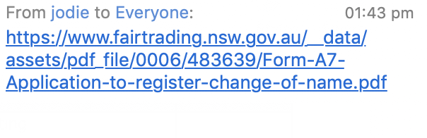  - Special resolution to change the name  - Resolved to change the name to Home Birth Access Sydney to Homebirth NSW –  - JP sending an email to committee members today  - Northern Sydney LHD- Survey results- KB to still go through  - Westmead – HB program nearly ready to go  - Birthings content- making a book for Jacqui and Jo so have lots of Birth Stories. (this birthings was supposed to be hard copy)  - If we have a successful raffle then we can afford to print it  - Rhea’s Book review – for birthings and website  - Rhea’s interview  - National Register -  - Project updates  - Hannah been doing Fab work  - Database with all the HB hospital programs  - Hilary- from ACM very supportive of us and the project  - 2nd midwife- issue shouldn’t be included on the DB  - Project is going really well and we will then have a great register of all the HB midwives and programs  - Questions around who’s going to managing it and updating the register  - Is it going to be on Homebirth Australia Website  - Maybe it should be an independent site etc. “Find a HB midwife Australia” something like that.  - How’s it going to be branded?  - Which domain to use?  - Who is going to manage it.  - Eg. 2 hours per quarter would be the commitment  - Maybe we can mange if they can use their budget to build it  - Memberships-  - 13 Janine  - 7 Jacqui  - Change of way for Midwife memberships  - Instead of per client membership  - But have a $$ membership for each midwife  - From Practice midwives- not getting memberships from them- KBW has offered to help yet they are still not responding.  - Offering flat prices – 180 PA for 20 Memberships? To discuss later costings  - JP build into the site- code for clients to log into.  - Discount 10% for midwives who pay up front for the year  - Benefits for then doing all the welcome packs at once. | JP  KB  VM  AP  JS  KB
Events
Natural pregnancy and parenting expo
- Natural Pregnancy Parenting Expo
- Partnering with Australian Breastfeeding Project
- Brush Farm House – Eastwood
- Date – February

- Picnic 25th October 10:30am
- FB event
- Petersham Park
- Requests now for the fundraising raffles prizes
- Photographer Grand Prize
- Need to look for other prizes within the raffle for the picnic
- Tix on the shop and website
- JPEG Raffle ticket $5 1 // 3 for $10 // 7 for $20
- Jodie load it up on the website- through Paypal

Other Business
- Next meeting 19th September 1pm ..

